Leo Chai

Mrs. Goldenburg E.

ENG4UA-04

17 March 2019

Rationale

I chose to write an online journal which investigates how the process of translating a text will change it’s meaning. The goal of my task is to demonstrate how languages are often not compatible due to their different conversions, and how people with different background interpret it.

One learning outcome of the course is understanding how language and meaning are shaped by culture and context. Specifically, for my task, I will investigate the difference between language conventions and how people of different culture background interpret texts differently.

The main audience of the text which I am writing will be people who are learning another language from a different culture background, as they need understand how people with different culture interpret language differently to translate their thoughts to another language while maintaining the same message. Specifically, I will analyze how translators change elements of a text when translating it between languages.

I will write an article published online, on Wall Street Journal. Having my text as an online journal allows me to use images and a variety of tools such as text style and spacing to organize my article. This is especially important as my journal contains text from other languages, and may become messy and hard to read if not well organized.

I chose a Chinese poem from around 800 CE and several of its English as the text that I will be analyzing. At this point in time, there will be minimal influences between the cultures, plus the two languages are from different language families. Thus, this maximizes the difference between the two languages, which helps me explain how languages may be incompatible with each other.

Word count: 278

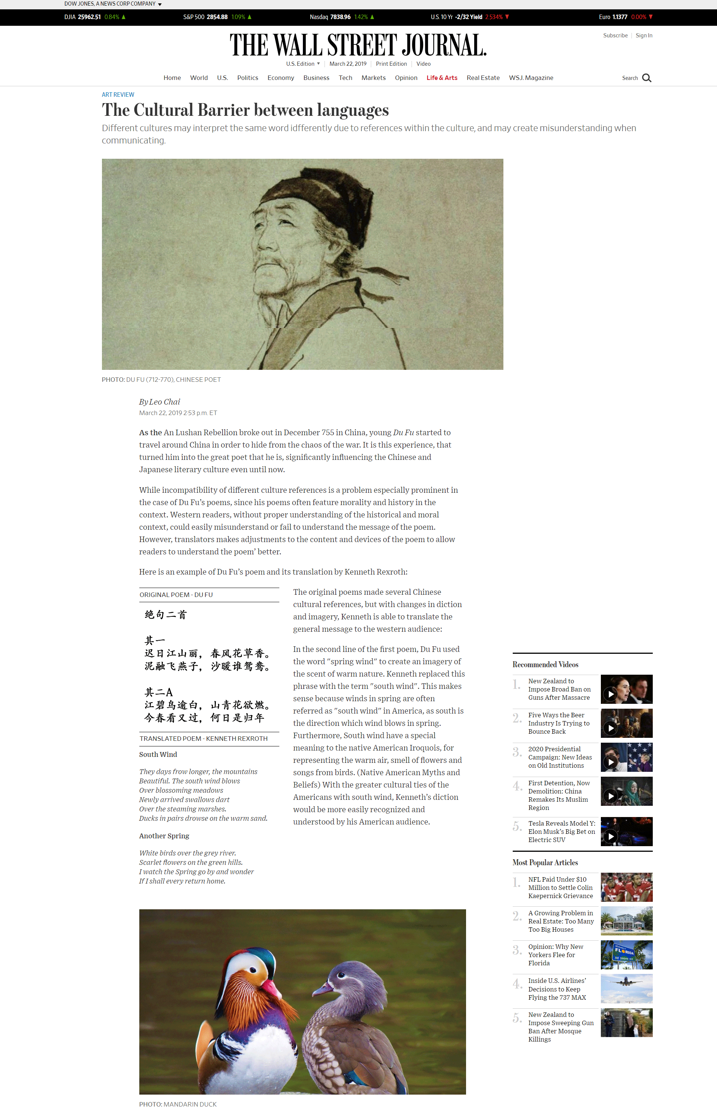

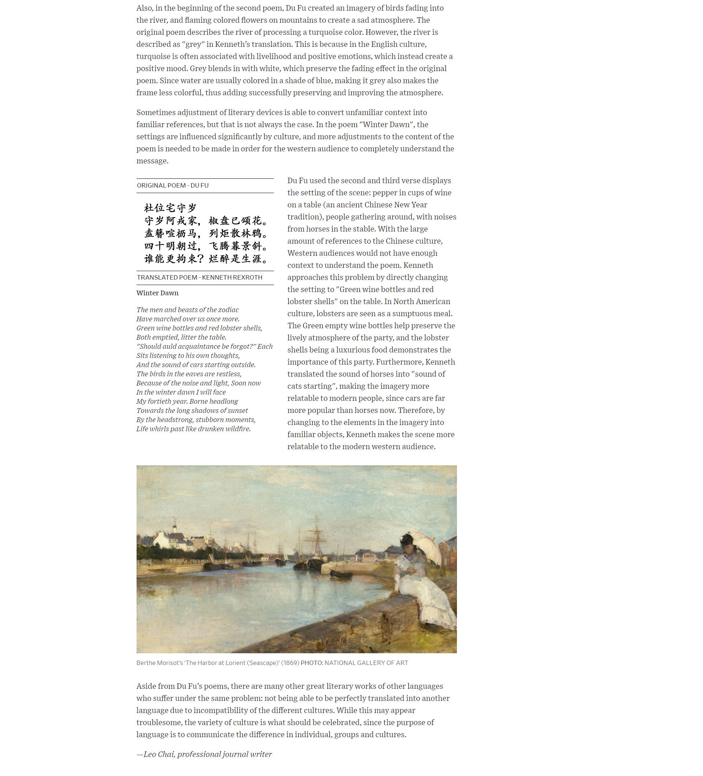

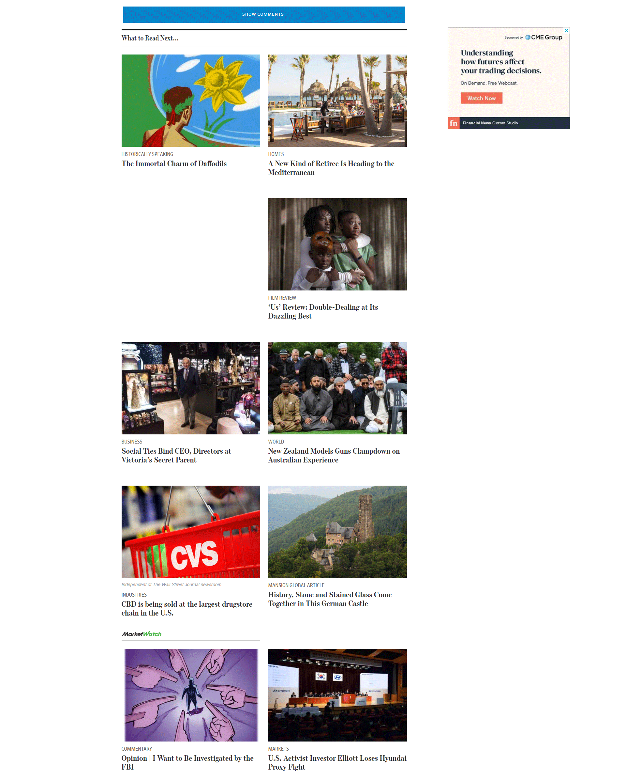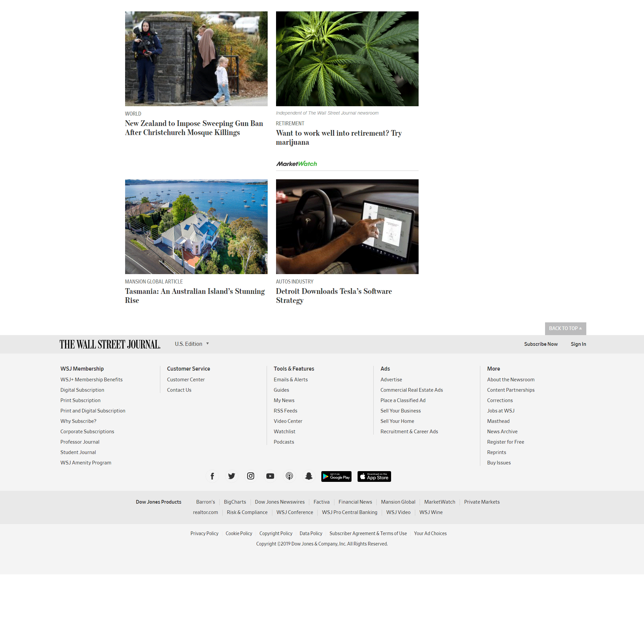

Word count:

Work Cited

Herdan, Innes, and Yee Chiang. *300 Tang Poems = Tang Shi San Bai Shou*. Yuan Dong Tu Shu Gong Si, 2000.

Lewis, Mary Tompkins. “'Berthe Morisot, Woman Impressionist' Review: A Legacy Restored.” *The Wall Street Journal*, Dow Jones & Company, 19 Mar. 2019, www.wsj.com/articles/berthe-morisot-woman-impressionist-review-a-legacy-restored-11553021609?mod=rsswn.

Lowenstein, Tom, and Piers Vitebsky. *Native American Myths and Beliefs*. Rosen Publishing Group, 2012.

Rexroth, Kenneth. *One Hundred Poems from the Chinese*. New Directions Pub., 2013.